Белоусов Евгений
ИУ5-51
Рубежный контроль №2
РИП

1.Вывод программы
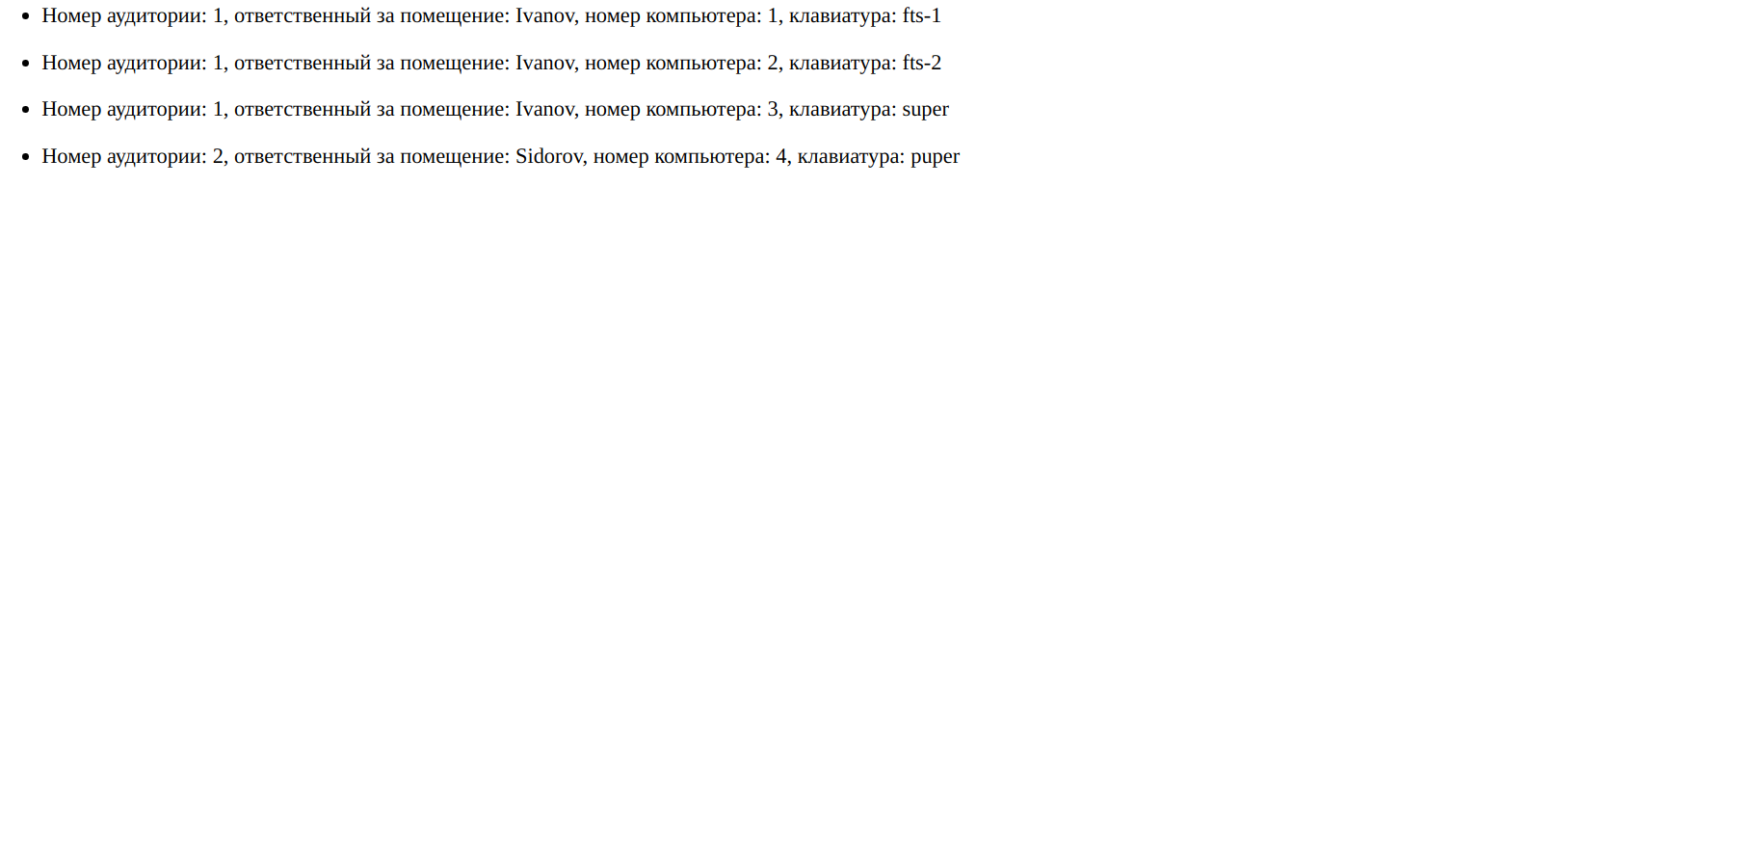
2. Исходный код
<!DOCTYPE html>
<html lang="en">
<head>
<meta charset="UTF-8">
<title>RK2</title>
</head>
<body>
{% for c in computer_list %}
<ul>
<li>Номер аудитории: {{ c.computer_class_number }},
ответственный за помещение: {{ c.computer_class_person }},
номер компьютера: {{ c.computer_number }},
клавиатура: {{ c.keyboard }}</li>
</ul>
{% endfor %}
</body>
</html>

# -*- coding: utf-8 -*-
from __future__ import unicode_literals
from django.db import models
# Create your models here.
class ComputerClass(models.Model):
response_person = models.CharField(max_length=100)
number = models.IntegerField()
class Computer(models.Model):
number = models.IntegerField()
computer_class = models.ForeignKey(ComputerClass, on_delete=models.CASCADE)
keyboard = models.CharField(max_length=50)

# -*- coding: utf-8 -*-
from __future__ import unicode_literals
from django.contrib import admin
# Register your models here.
from .models import ComputerClass, Computer
admin.site.register(ComputerClass)
admin.site.register(Computer)

# -*- coding: utf-8 -*-
from __future__ import unicode_literals
from django.shortcuts import render
from django.http import HttpResponse
from .models import Computer, ComputerClass
from django.http import Http404
# Create your views here.
def computers_view(request):
computer_class_list = ComputerClass.objects.order_by('number')
print (computer_class_list)
output = []
for computer_class in computer_class_list:
computer_list = Computer.objects.filter(computer_class=computer_class)
print( computer_list)
for computer in computer_list:
string ={'computer_class_number':computer_class.number,
'computer_class_person':computer_class.response_person,
'computer_number':computer.number,
'keyboard':computer.keyboard}
output.append(string)
if output is None:
raise Http404("Computers does not exist")
context = {'computer_list' : output}
return render(request, 'index.html', context)

"""RK2 URL Configuration
The `urlpatterns` list routes URLs to views. For more information please see:
https://docs.djangoproject.com/en/1.11/topics/http/urls/
Examples:
Function views
1. Add an import: from my_app import views
2. Add a URL to urlpatterns: url(r'^$', views.home, name='home')
Class-based views
1. Add an import: from other_app.views import Home
2. Add a URL to urlpatterns: url(r'^$', Home.as_view(), name='home')
Including another URLconf
1. Import the include() function: from django.conf.urls import url, include
2. Add a URL to urlpatterns: url(r'^blog/', include('blog.urls'))
"""
from django.conf.urls import url
from django.contrib import admin
from computers import views
urlpatterns = [
url(r'^admin/', admin.site.urls),
url(r'', views.computers_view)
]

"""
Django settings for RK2 project.
Generated by 'django-admin startproject' using Django 1.11.27.
For more information on this file, see
https://docs.djangoproject.com/en/1.11/topics/settings/
For the full list of settings and their values, see
https://docs.djangoproject.com/en/1.11/ref/settings/
"""
import os
# Build paths inside the project like this: os.path.join(BASE_DIR, ...)
BASE_DIR = os.path.dirname(os.path.dirname(os.path.abspath(__file__)))
# Quick-start development settings - unsuitable for production
# See https://docs.djangoproject.com/en/1.11/howto/deployment/checklist/
# SECURITY WARNING: keep the secret key used in production secret!
SECRET_KEY = '5v(jfcd_st!_-xhw8o2o6cmv2dv#5^oghvn36&k&h%)$j5mjl)'
# SECURITY WARNING: don't run with debug turned on in production!
DEBUG = True
ALLOWED_HOSTS = []
# Application definition
INSTALLED_APPS = [
'django.contrib.admin',
'django.contrib.auth',
'django.contrib.contenttypes',
'django.contrib.sessions',
'django.contrib.messages',
'django.contrib.staticfiles',
'computers.apps.ComputersConfig'
]
MIDDLEWARE = [
'django.middleware.security.SecurityMiddleware',
'django.contrib.sessions.middleware.SessionMiddleware',
'django.middleware.common.CommonMiddleware',
'django.middleware.csrf.CsrfViewMiddleware',
'django.contrib.auth.middleware.AuthenticationMiddleware',
'django.contrib.messages.middleware.MessageMiddleware',
'django.middleware.clickjacking.XFrameOptionsMiddleware',
]
ROOT_URLCONF = 'RK2.urls'
TEMPLATES = [
{
'BACKEND': 'django.template.backends.django.DjangoTemplates',
'DIRS': [],
'APP_DIRS': True,
'OPTIONS': {
'context_processors': [
'django.template.context_processors.debug',
'django.template.context_processors.request',
'django.contrib.auth.context_processors.auth',
'django.contrib.messages.context_processors.messages',
],
},
},
]
WSGI_APPLICATION = 'RK2.wsgi.application'
# Database
# https://docs.djangoproject.com/en/1.11/ref/settings/#databases
DATABASES = {
'default': {
'ENGINE': 'django.db.backends.sqlite3',
'NAME': os.path.join(BASE_DIR, 'db.sqlite3'),
}
}
# Password validation
# https://docs.djangoproject.com/en/1.11/ref/settings/#auth-password-validators
AUTH_PASSWORD_VALIDATORS = [
{
'NAME': 'django.contrib.auth.password_validation.UserAttributeSimilarityValidator',
},
{
'NAME': 'django.contrib.auth.password_validation.MinimumLengthValidator',
},
{
'NAME': 'django.contrib.auth.password_validation.CommonPasswordValidator',
},
{
'NAME': 'django.contrib.auth.password_validation.NumericPasswordValidator',
},
]
# Internationalization
# https://docs.djangoproject.com/en/1.11/topics/i18n/
LANGUAGE_CODE = 'en-us'
TIME_ZONE = 'UTC'
USE_I18N = True
USE_L10N = True
USE_TZ = True
# Static files (CSS, JavaScript, Images)
# https://docs.djangoproject.com/en/1.11/howto/static-files/
STATIC_URL = '/static/'

